IMDB MOVIES DATA ANALYSIS USING SQL

Project Report

Submitted by: Prince Rajwar
Course: Data Analyst
Project Domain: Movie Data Analysis
Tool Used: MySQL Workbench
Database Name: project_movie_database
Submission Date: 25th October 2026

1. Project Overview
The IMDb Movies SQL Project focuses on analyzing movie and director data using MySQL. The project involves retrieving movie information, exploring director details, identifying popular and high-revenue movies, analyzing movie ratings, and examining directors' performance.
SQL queries are used to extract relevant information from the database and answer 13 predefined analytical questions. The project helps develop practical skills in data retrieval, filtering, sorting, aggregation, and joining related tables.

2. Project Objectives
- Retrieve and explore movie and director information.
- Identify the most popular movies based on popularity scores.
- Find the highest-revenue movies.
- Analyze movie ratings and release dates.
- Identify directors based on movie counts and total movie revenue.
- Practice SQL querying techniques using a relational database.

3. Dataset Description
The project database is named project_movie_database and contains two tables: movies and directors.
3.1 Movies Table
The Movies table contains information about movies, including their titles, budgets, popularity scores, release dates, revenue, average ratings, vote counts, and director IDs.
Important columns include:
- id: Movie identifier
- original_title: Original movie title
- budget: Movie budget
- popularity: Movie popularity score
- release_date: Movie release date
- revenue: Movie revenue
- vote_average: Average movie rating
- vote_count: Number of votes
- director_id: Identifier linking a movie to its director
3.2 Directors Table
The Directors table contains information about directors.
Important columns include:
- id: Director identifier
- name: Director name
- gender: Gender code
- uid: Unique identifier
- department: Director department
3.3 Database Size
The initial database returned 47 movie records and 2,349 director records.

4. Tools and Technologies
MySQL Workbench: Used to connect to the database, execute SQL queries, and inspect query results.
SQL (Structured Query Language): Used to retrieve, filter, sort, group, and analyze the movie and director data.
SQL Concepts Used
- SELECT — Retrieve data from tables.
- WHERE — Filter records using conditions.
- LIKE and IN — Search for matching names.
- ORDER BY — Sort results.
- LIMIT — Restrict the number of returned records.
- Aggregate functions such as COUNT() and SUM().
- GROUP BY — Calculate director-level summaries.
- JOIN — Combine movie and director information.

5. Questions, SQL Queries and Results:

- Can you get all data about movies?
Objective: To retrieve all records and columns from the Movies table to understand the available movie information.
Query:-
SELECT * FROM movies;
Output:-

Interpretation: The query displays all available movie records and their attributes from the Movies table. This helps understand the dataset structure and the information available for further analysis.

- How do you get all data about directors?
Objective: To retrieve all records and columns from the Directors table to explore director information.
Query:-
SELECT * FROM directors;
Output:-
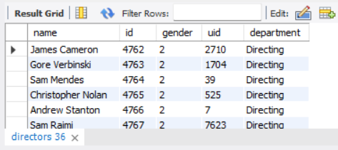
Interpretation: The query displays all available director records and their attributes. This helps understand the director dataset and identify the fields required for linking directors with movies.

- Check how many movies are present in IMDB.
Objective: To calculate the total number of movie records available in the Movies table.
Query:-
SELECT count(*) as Total_Movies
FROM movies;
Output:-
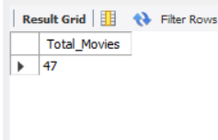
Interpretation: The COUNT() function returns the total number of movie records in the current dataset. The result is 47 Movies present in this table.

- Find these 3 directors: James Cameron ; Luc Besson ; John Woo
Objective: To search for the records of James Cameron, Luc Besson, and John Woo in the Directors table.
Query:-
SELECT * FROM directors
WHERE name IN (
'James Cameron',
'Luc Besson',
'John Woo' );
Output:-

Interpretation: The query identifies which of the three specified directors are present in the dataset and retrieves their available details.

- Find all directors with name starting with S.
Objective: To identify all directors whose names begin with the letter S.
Query:-
SELECT *
FROM directors
WHERE name LIKE "S%";
Output:-
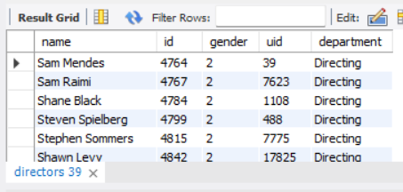
Interpretation: The LIKE 'S%' condition filters the Directors table to return matching names. There are Total 173 Directors in this table who’s name is starting with S.

- Count female directors.
Objective: To calculate the number of female directors using the gender codes provided in the dataset, where 1 represents female.
Query:-
SELECT count(*) AS Total_Female_Directors
FROM directors
WHERE gender=1;
Output:-
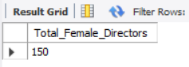
Interpretation: The COUNT() function counts director records with gender = 1. There are total 150 female director records available in the current dataset.

- Find the name of the 10th first women directors?
Objective: To identify the top 10 female director from directors dataset.
Query:-
SELECT name
FROM directors
WHERE gender=1
LIMIT 10;
Output:-

Interpretation: The query results the top 10 female Directors name from the director dataset.

- What are the 3 most popular movies?
Objective: To identify the three movies with the highest popularity scores in the Movies table.
Query:-
SELECT title AS Popular_Movies,
popularity AS Popularity_No
FROM movies
ORDER BY popularity desc
LIMIT 3;
Output:-
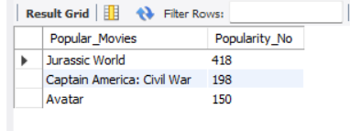
Interpretation: The query sorts movies by popularity in descending order and returns the top three records. These movies have the highest recorded popularity scores in the available dataset.

- What are the 3 most bankable movies?
Objective: To identify the three movies with the highest revenue generated.
Query:-
SELECT title AS Bankable_Movies,
revenue AS Total_Revenue
FROM movies
ORDER BY revenue DESC
LIMIT 3;
Output:-
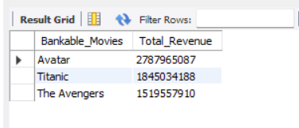
Interpretation: The query sorts movies by revenue in descending order and returns the top three highest-revenue movies. Here, bankable is interpreted as having the highest total revenue, rather than profitability, because profit would require comparing revenue against costs.

- What is the most awarded average vote since the January 1st, 2000?
Objective: To identify the highest-rated movie released on or after January 1, 2000, using its average vote rating.
Query:-
SELECT title AS Movie_Name,
vote_average AS Awarded_Average_Vote,
release_date AS Released_Date
FROM movies
WHERE release_date >= '2000-01-01'
ORDER BY vote_average DESC
LIMIT 3;
Output:-

Interpretation: The query filters movies by release date and sorts them by average rating in descending order. The highest-rated matching movie is returned. This movies has equal number of average vote rating.

- Which movie(s) were directed by Brenda Chapman?
Objective: To identify movies associated with ‘Brenda Chapman’ by joining the Movies and Directors tables.
Query:-
SELECT title AS Movie_Name,
d.name AS Director_Name
FROM movies as m
INNER JOIN directors as d
ON m.director_id=d.id
WHERE name ="Brenda Chapman";
Output:-

Interpretation: The query matches movie director IDs with director IDs and filters for Brenda Chapman. But there is no matching records were found in the available dataset.

- Which director made the most movies?
Objective: To identify the director associated with the highest number of movies in the available dataset.
Query:-
SELECT d.name AS Director_Name,
COUNT(m.id) AS Total_Movies
FROM directors AS d
INNER JOIN movies AS m
ON d.id=m.director_id
GROUP BY d.id,d.name
ORDER BY Total_Movies DESC
LIMIT 3;
Output:-
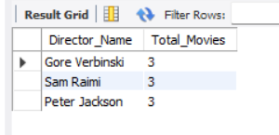
Interpretation: The query groups movie records by director and counts the movies associated with each director. There are three Directors who has same and highest number of Movies. The Highest number of movies is 3.

- Which director is the most bankable?
Objective: To identify the director whose associated movies have the highest combined revenue.
Query:-
SELECT d.name AS Director_Name,
SUM(m.revenue) AS Total_Revenue
FROM directors AS d
INNER JOIN movies AS m
ON d.id=m.director_id
GROUP BY d.id,d.name
ORDER BY Total_Revenue DESC
LIMIT 1;
Output:-
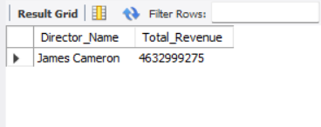
Interpretation: The query joins the Movies and Directors tables, sums movie revenue for each director, and ranks directors by total revenue. ‘James Cameron’ is the name of the Director who has highest combined Revenue 4,63,29,99,275.

6. Key Findings
This section summarizes the findings obtained from the executed SQL queries.
- The three most popular movies were identified using the popularity column.
- The three highest-revenue movies were identified using the revenue column.
- Movie ratings and release dates were examined to identify highly rated movies released since January 1, 2000.
- Director-level movie counts were calculated to identify directors with the highest number of movies.
- Total movie revenue was aggregated to identify the most bankable director in the available dataset.

7. Challenges and Limitations
The current project database contains 47 movie records and 2,349 director records according to the initial checks. Therefore, the analysis represents the available project dataset and may not represent the complete IMDb movie collection.
Some requested directors or movie relationships may not be present in the available records. Results should be interpreted according to the data actually available.

8. Conclusion
The IMDb Movies SQL Project provided practical experience in querying and analyzing relational data using MySQL Workbench. The project involved retrieving movie and director information, analyzing popularity and revenue, examining ratings, and comparing director-level performance.
By completing the project, practical knowledge of SQL filtering, sorting, aggregation and joins was strengthened. These techniques are useful for data analysis and extracting insights from structured datasets.

